Geometric Figure Decomposition

Definition
# Source: AI Source: Provided by: [Data Path: Persons Table -> ID Column: 1, Name_En Column: Motasem Essam] -> From: [ChatGPT] on [7/25/2026]
Geometric Figure Decomposition is the process of dividing a complex geometric figure into two or more simpler geometric figures or components to make it easier to analyze, measure, construct, or understand.
The resulting components may include triangles, rectangles, squares, circles, semicircles, polygons, or other geometric regions.

Simple Definition
# Source: AI Source: Provided by: [Data Path: Persons Table -> ID Column: 1, Name_En Column: Motasem Essam] -> From: [ChatGPT] on [7/25/2026]
Geometric figure decomposition is breaking a complex geometric figure into simpler parts that can be studied or calculated separately.
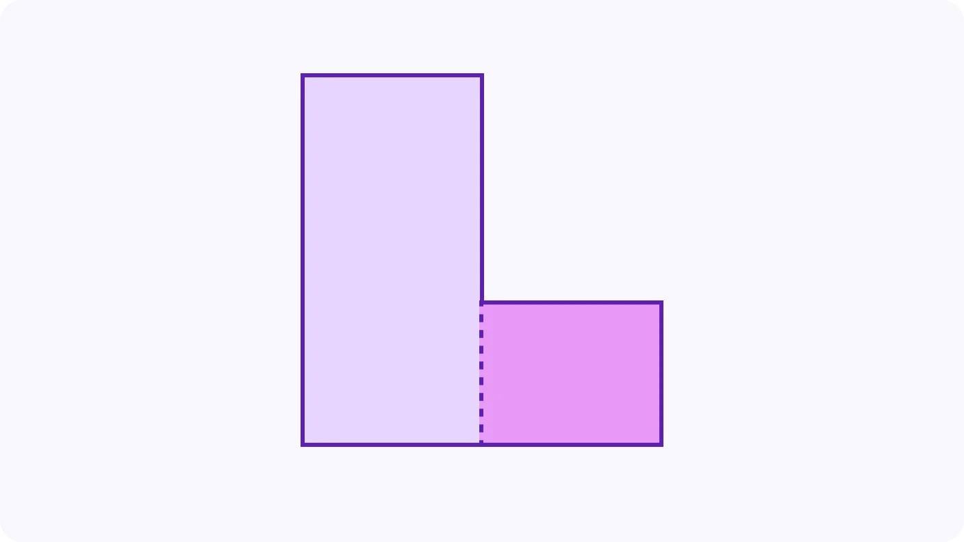
For example, an L-shaped region can be decomposed into two rectangles to calculate its total area.

Main Classification
# Source: AI Source: Provided by: [Data Path: Persons Table -> ID Column: 1, Name_En Column: Motasem Essam] -> From: [ChatGPT] on [7/25/2026]
The following is a practical classification based on how a geometric figure is divided. These categories describe different methods and are not mutually exclusive.

1. Rectangular Decomposition
# Source: AI Source: Provided by: [Data Path: Persons Table -> ID Column: 1, Name_En Column: Motasem Essam] -> From: [ChatGPT] on [7/25/2026]
Dividing a figure into rectangles or squares.
Example: An L-shaped region divided into two rectangles.
Purpose: Simplifies area and perimeter calculations.
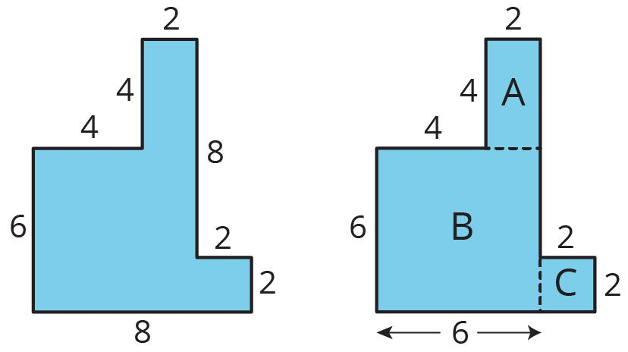

2. Triangular Decomposition
# Source: AI Source: Provided by: [Data Path: Persons Table -> ID Column: 1, Name_En Column: Motasem Essam] -> From: [ChatGPT] on [7/25/2026]
Dividing a polygon or another figure into triangles.
Example: A pentagon divided into three triangles by drawing diagonals from one vertex.
Purpose: Useful for calculating area and applying triangle theorems.
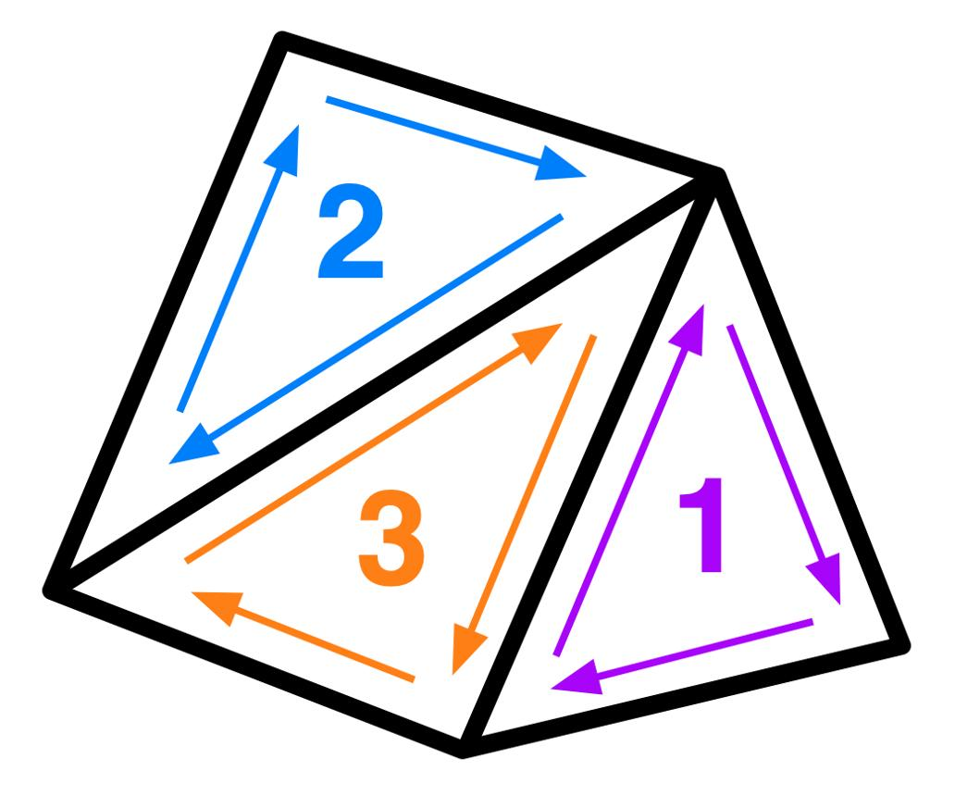

3. Mixed-Shape Decomposition
# Source: AI Source: Provided by: [Data Path: Persons Table -> ID Column: 1, Name_En Column: Motasem Essam] -> From: [ChatGPT] on [7/25/2026]
Dividing a composite figure into different types of shapes.
Example: A figure consisting of a rectangle and a semicircle separated into those two components.
Purpose: Allows the use of different formulas for each component.
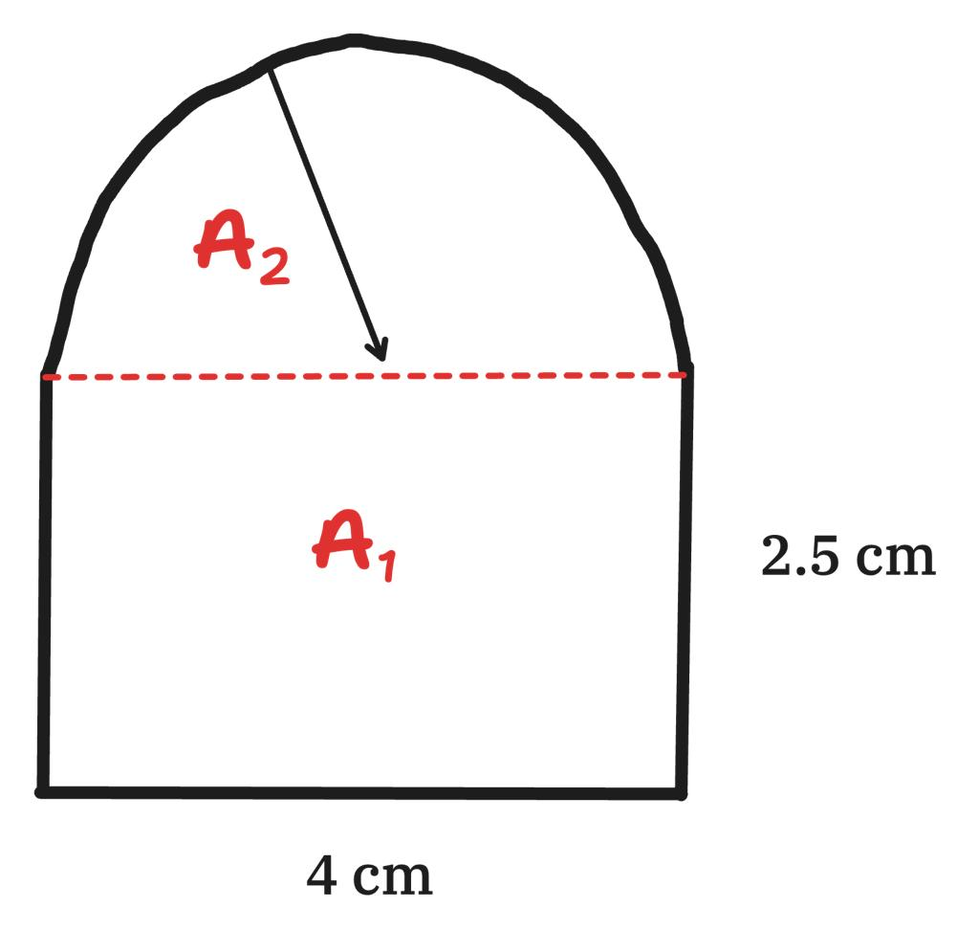

4. Equal-Partition Decomposition
# Source: AI Source: Provided by: [Data Path: Persons Table -> ID Column: 1, Name_En Column: Motasem Essam] -> From: [ChatGPT] on [7/25/2026]
Dividing a figure into smaller parts that have equal areas or are congruent.
Example: A square divided into four equal smaller squares.
Purpose: Useful for symmetry, fractions, ratios, and area comparisons.
Equal area does not necessarily mean that the parts are congruent.
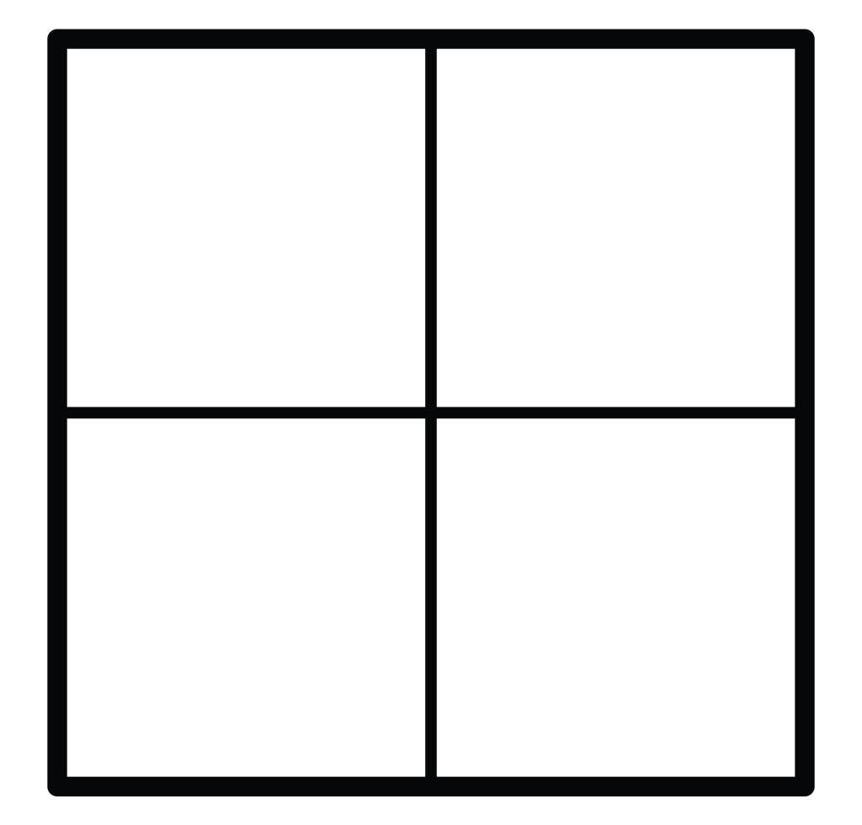

5. Subdivision by Lines or Segments
# Source: AI Source: Provided by: [Data Path: Persons Table -> ID Column: 1, Name_En Column: Motasem Essam] -> From: [ChatGPT] on [7/25/2026]
Dividing a figure by drawing internal line segments, diagonals, medians, or other constructed lines.
Example: Drawing a diagonal in a rectangle to divide it into two triangles.
Purpose: Reveals internal relationships and creates simpler subfigures.
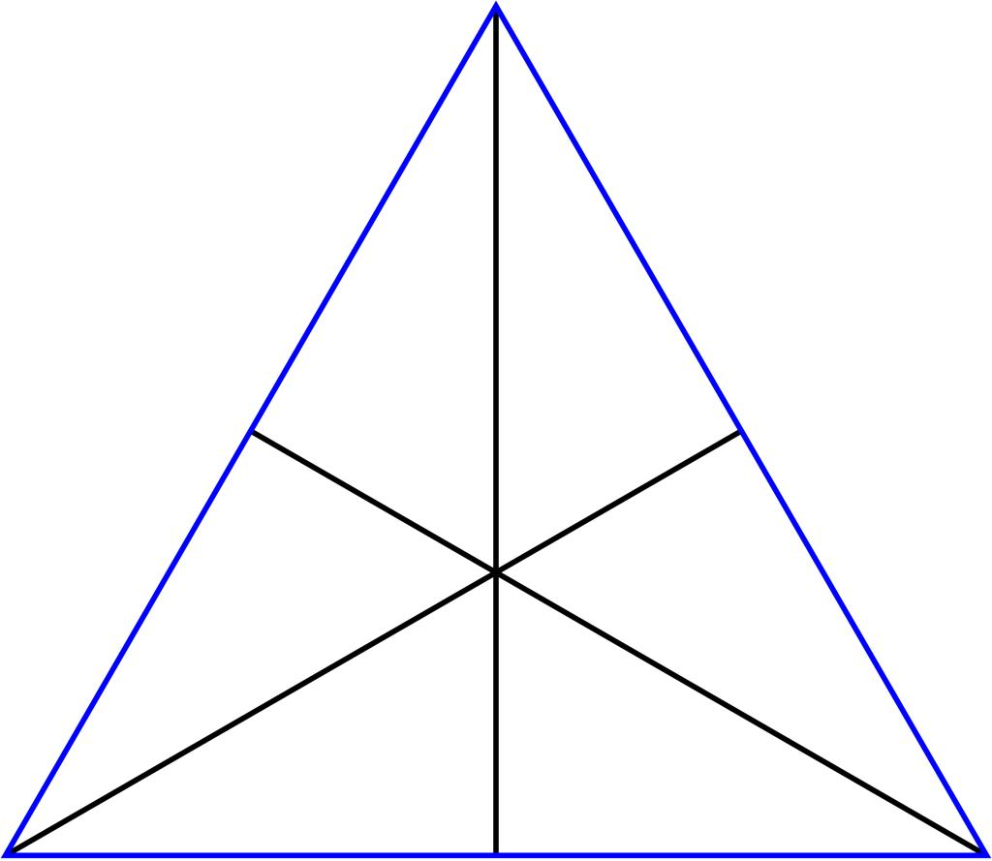

6. Circular Decomposition
# Source: AI Source: Provided by: [Data Path: Persons Table -> ID Column: 1, Name_En Column: Motasem Essam] -> From: [ChatGPT] on [7/25/2026]
Dividing a circular region into sectors, segments, or other simpler regions.
Example: A circle divided into six equal sectors.
Purpose: Simplifies calculations involving circular areas and angles.
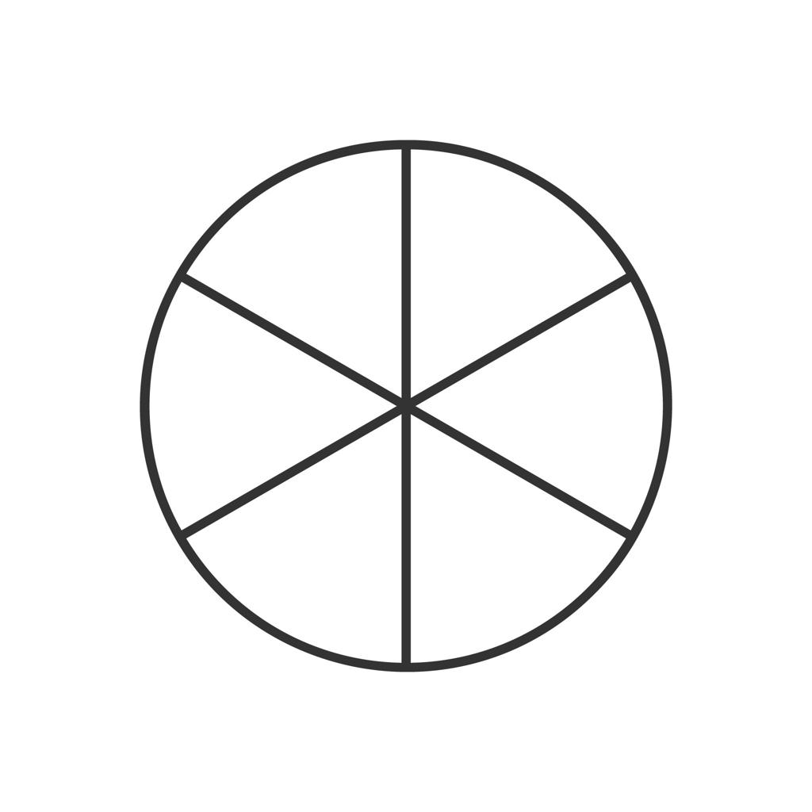

Mathematical Examples

Example 1: Decomposing an L-Shaped Figure
# Source: AI Source: Provided by: [Data Path: Persons Table -> ID Column: 1, Name_En Column: Motasem Essam] -> From: [ChatGPT] on [7/25/2026]
Suppose an L-shaped region can be divided into two non-overlapping rectangles:
- Rectangle 1: length $8$, width $3$.
- Rectangle 2: length $4$, width $2$.
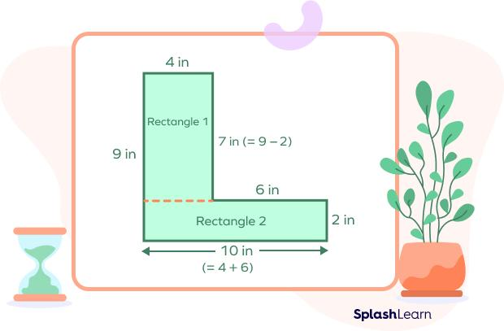
The total area is the sum of the component areas:
$$A=A_{1}+A_{2}$$
$$A=\left(8\right)\left(3\right)+\left(4\right)\left(2\right)$$
$$\boxed{A=32\text{ square units}}$$
This method works because the rectangles cover the whole region without overlapping interiors or leaving gaps.

Example 2: Decomposing a Polygon into Triangles
# Source: AI Source: Provided by: [Data Path: Persons Table -> ID Column: 1, Name_En Column: Motasem Essam] -> From: [ChatGPT] on [7/25/2026]
A pentagon can be divided into three triangles by drawing diagonals from one vertex.
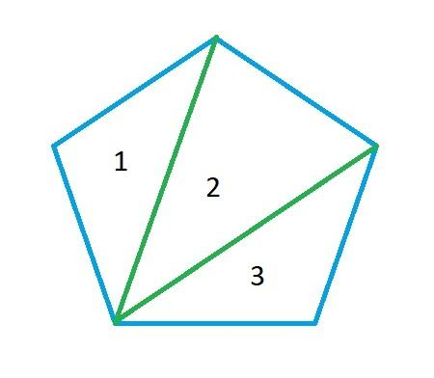
For a convex polygon with $n$sides, drawing diagonals from one vertex creates $n-2$triangles.
For a pentagon:
$$n-2=5-2=3$$
Therefore, its area is the sum of the three triangle areas:
$$A_{\text{pentagon}}=A_{1}+A_{2}+A_{3}$$

Example 3: Decomposing a Composite Circular Figure
# Source: AI Source: Provided by: [Data Path: Persons Table -> ID Column: 1, Name_En Column: Motasem Essam] -> From: [ChatGPT] on [7/25/2026]
Suppose a region consists of a rectangle with a semicircle attached to one side. The rectangle has length $10$, width $4$, and the semicircle has diameter $4$.
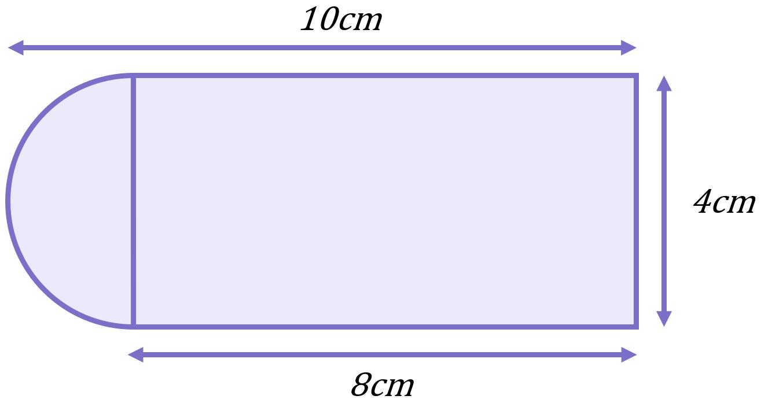
The semicircle's radius is $r=2$.
$$A_{\text{rectangle}}=10\left(4\right)=40$$
$$A_{\text{semicircle}}=\frac{1}{2}π{\left(2\right)}^{2}=2π$$
Thus,
$$\boxed{A=40+2π}$$
square units.

Important Rules and Formulas

Area of a decomposed figure
# Source: AI Source: Provided by: [Data Path: Persons Table -> ID Column: 1, Name_En Column: Motasem Essam] -> From: [ChatGPT] on [7/25/2026]
If a figure is partitioned into non-overlapping regions that cover it completely, then
$$\boxed{A_{\text{total}}=\sum_{i=1}^{n}{A_{i}}}$$

Volume of a decomposed solid
# Source: AI Source: Provided by: [Data Path: Persons Table -> ID Column: 1, Name_En Column: Motasem Essam] -> From: [ChatGPT] on [7/25/2026]
If a solid is divided into non-overlapping solids that cover it completely, then
$$\boxed{V_{\text{total}}=\sum_{i=1}^{n}{V_{i}}}$$

Subtraction method
# Source: AI Source: Provided by: [Data Path: Persons Table -> ID Column: 1, Name_En Column: Motasem Essam] -> From: [ChatGPT] on [7/25/2026]
Sometimes it is easier to remove an unwanted region rather than divide the figure into many parts:
$$\boxed{A_{\text{remaining}}=A_{\text{whole}}-A_{\text{removed}}}$$
For example, the area of a square with a circular hole is
$$A=s^{2}-πr^{2}$$
provided the circle lies entirely inside the square.

Perimeter caution
# Source: AI Source: Provided by: [Data Path: Persons Table -> ID Column: 1, Name_En Column: Motasem Essam] -> From: [ChatGPT] on [7/25/2026]
Unlike area, perimeters of adjacent components cannot always be added directly. Shared internal boundaries must not be counted as part of the outer perimeter.

Geometric Figure Decomposition vs. Composition
# Source: AI Source: Provided by: [Data Path: Persons Table -> ID Column: 1, Name_En Column: Motasem Essam] -> From: [ChatGPT] on [7/25/2026]
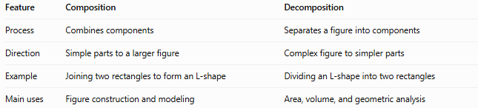
Feature | Composition | Decomposition
Process | Combines components | Separates a figure into components
Direction | Simple parts to a larger figure | Complex figure to simpler parts
Example | Joining two rectangles to form an L-shape | Dividing an L-shape into two rectangles
Main uses | Figure construction and modeling | Area, volume, and geometric analysis
The two processes are complementary:
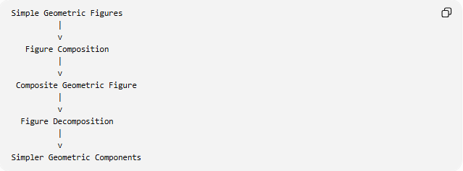
Simple Geometric Figures
|
v
Figure Composition
|
v
Composite Geometric Figure
|
v
Figure Decomposition
|
v
Simpler Geometric Components

Classification Summary
# Source: AI Source: Provided by: [Data Path: Persons Table -> ID Column: 1, Name_En Column: Motasem Essam] -> From: [ChatGPT] on [7/25/2026]
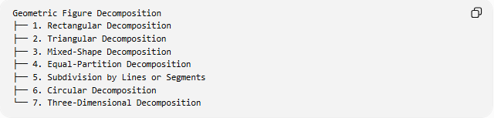
Geometric Figure Decomposition
├── 1. Rectangular Decomposition
├── 2. Triangular Decomposition
├── 3. Mixed-Shape Decomposition
├── 4. Equal-Partition Decomposition
├── 5. Subdivision by Lines or Segments
├── 6. Circular Decomposition
└── 7. Three-Dimensional Decomposition
This is a practical classification, not a universally standardized list. A single decomposition may belong to several categories—for example, a circle divided into equal sectors is both circular and equal-partition decomposition.

Key Points
# Source: AI Source: Provided by: [Data Path: Persons Table -> ID Column: 1, Name_En Column: Motasem Essam] -> From: [ChatGPT] on [7/25/2026]
- Decomposition breaks a complex figure into simpler components.
- Components should cover the intended figure without unintended gaps or overlaps.
- Area and volume can be calculated by adding component measurements.
- Subtraction is useful when the figure contains holes or missing regions.
- Internal shared boundaries must be excluded when finding the outer perimeter.
- Different valid decompositions of the same figure can produce the same total area or volume.

Conclusion
# Source: AI Source: Provided by: [Data Path: Persons Table -> ID Column: 1, Name_En Column: Motasem Essam] -> From: [ChatGPT] on [7/25/2026]
Geometric Figure Decomposition is a method of breaking a complex geometric figure into simpler shapes or regions. It is particularly useful for calculating area, perimeter, and volume, as well as for geometric proofs, construction, and spatial reasoning.

